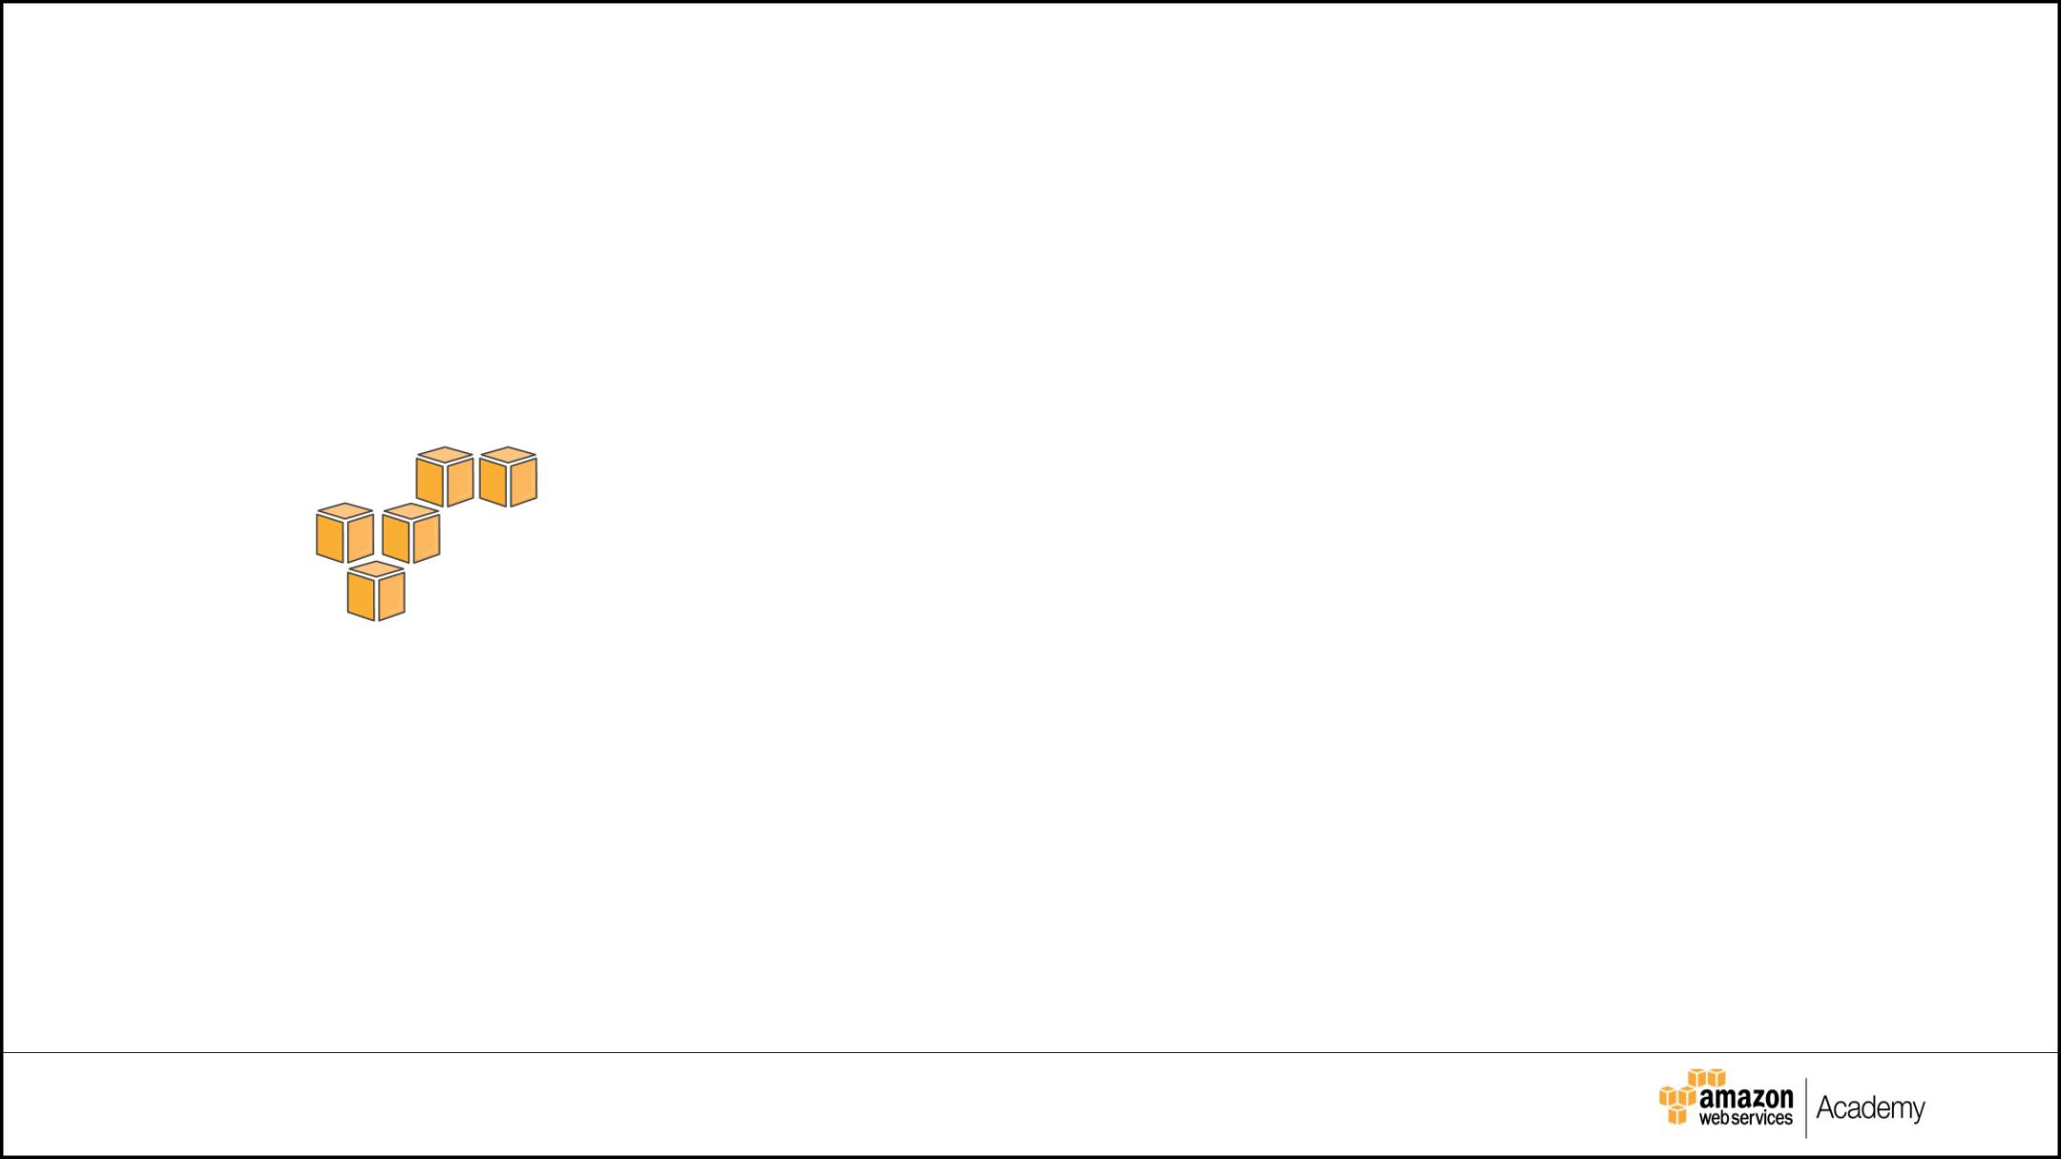

**Final Project**

*GoGreen Insurance Company*

|  |  |  |  |
| --- | --- | --- | --- |
| © 2017 Amazon Web | Inc. and its affiliates. All rights reserved. | **1** |  |
| © 2016 Amazon Web ServicServices,Inc.and its affil ates. All rights reserved. | |  |

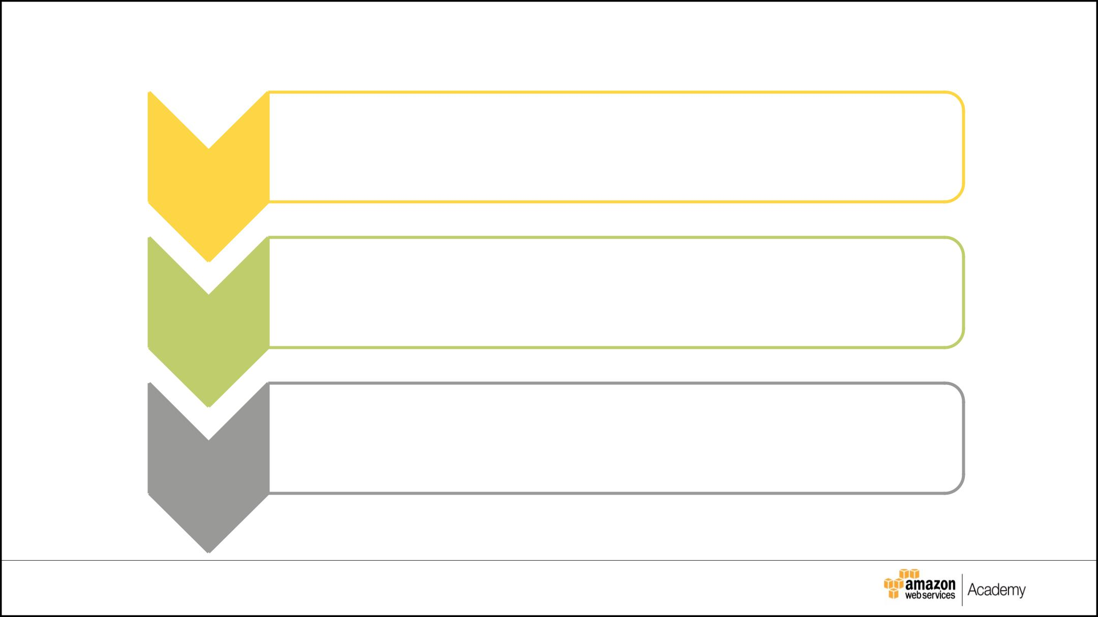

**Final Project Overview**

* + Analyze needs and current architecture

1. • Design an AWS solution meeting the provided requirements
   * Provide solution details in the Project Plan tables provided
2. • Create an architecture diagram demonstrating the solution
   * Lab environment:
3. implement based on lab instructions.

|  |  |  |  |
| --- | --- | --- | --- |
| © 2017 Amazon Web | Inc. and its affiliates. All rights reserved. | **2** |  |
| © 2016 Amazon Web ServicServices,Inc.and its affil ates. All rights reserved. | |  |

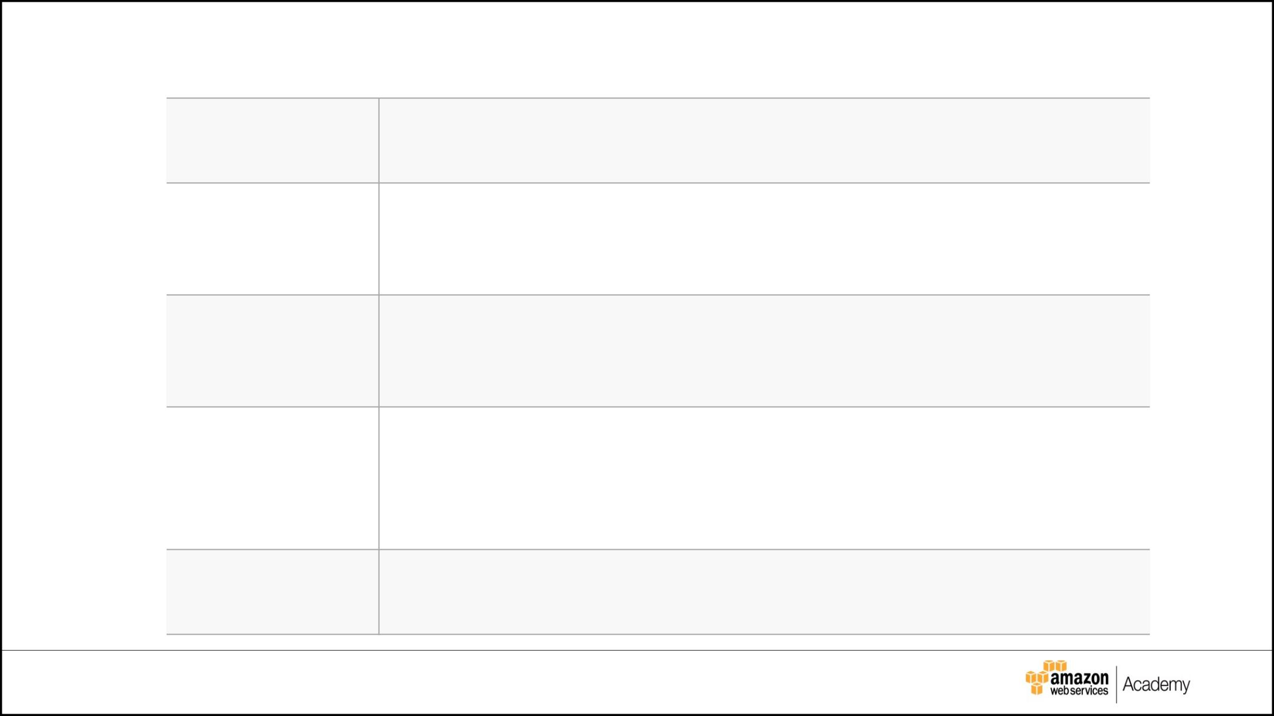

**Background**

**Company:** GoGreen Insurance Company

**Locations:** Europe, South America

Southern California (headquarters)

**Application:** CRM web application allows sales personnel to input and edit customer data.

**Technical:** 3-tier web app stores customer data and documents. Converts the documents into multiple formats (e.g. images

for web/mobile)

**Goal:** Go *paperless* for all user data, documents and pictures

|  |  |  |  |
| --- | --- | --- | --- |
| © 2017 Amazon Web | Inc. and its affiliates. All rights reserved. | **3** |  |
| © 2016 Amazon Web ServicServices,Inc.and its affil ates. All rights reserved. | |  |



**Issues**

Problems with the existing application include:

* On-premises performance and reliability issues occur.
* The architecture is continuously overprovisioned to handle growth.

*This process has occurred three times in the last year.*

* Growing the architecture has become too expensive.
* The procurement process takes 20 days.
* Deployment takes a week.
* The entire process costs in excess of $100,000.

The plan is to move the application into the cloud.

|  |  |  |  |
| --- | --- | --- | --- |
| © 2017 Amazon Web | Inc. and its affiliates. All rights reserved. | **4** |  |
| © 2016 Amazon Web ServicServices,Inc.and its affil ates. All rights reserved. | |  |



**Current Architecture**

**Web Tier**

* Six virtual machines (Two vCPUs/4-GB memory)
* SUSE Linux Enterprise Server 12
* Apache web server
* PHP server and PHP files

**Application Tier**

▪

▪

▪

Five virtual machines (Four vCPUs/32-GB memory)

SUSE Linux Enterprise Server 12

Java SRE 7/Java application files

**Database Tier**

* Two virtual machines (Eight vCPUs/48-GB memory /5.5-TB storage)
* SUSE Linux Enterprise Server 12
* MySQL 5.6.22 database cluster

|  |  |  |  |
| --- | --- | --- | --- |
| © 2017 Amazon Web | Inc. and its affiliates. All rights reserved. | **5** |  |
| © 2016 Amazon Web ServicServices,Inc.and its affil ates. All rights reserved. | |  |



**Requirements (1 of 4)**

**Environment**

* Infrastructure will be managed by members of the new Cloud Team.

▪

▪

All data must be encrypted in transit and at rest.

Infrastructure should be secured using a defense-in-depth approach.

* Users should connect to stateless web servers.
* A baseline for the number and type of instances needed should be established.
* Recovery Point Objective for the application is four hours.
* A user base that is expected to grow 90% in the next three years must be supported.
* Documents and pictures must be kept for five years. However, these files are rarely requested after three months.
* To enhance availability and lower cost, managed services must be leveraged whenever possible.

|  |  |  |  |
| --- | --- | --- | --- |
| © 2017 Amazon Web | Inc. and its affiliates. All rights reserved. | **6** |  |
| © 2016 Amazon Web ServicServices,Inc.and its affil ates. All rights reserved. | |  |



**Requirements (2 of 4)**

**Web Tier**

* Architecture must be flexible and handle any peak in traffic or performance
* Servers are currently at 75% of memory capacity all the time. This number must decrease to between 50% and 60% when moved to AWS.
* Application administrators want to be notified by email if there are more than 100

“400 HTTP errors” per minute in the application.

* All instances in Web Tier should be tagged as “Key=Name” and “Value=web-tier”.

|  |  |  |  |
| --- | --- | --- | --- |
| © 2017 Amazon Web | Inc. and its affiliates. All rights reserved. | **7** |  |
| © 2016 Amazon Web ServicServices,Inc.and its affil ates. All rights reserved. | |  |



**Requirements (3 of 4)**

**Application Tier**

* Architecture must be flexible and handle any peak in performance
* Servers are currently at 90% of memory and CPU capacity all the time. This number must decrease to between 50% and 60% when moved to AWS.
* Overall memory and CPU utilization should not go above 80% and 75% respectively, or below 30% for each.
* Internet access for patching and updates must be available without exposing the servers.
* All instances in Application Tier should be tagged as “Key=Name” and “Value=app-tier”.

|  |  |  |  |
| --- | --- | --- | --- |
| © 2017 Amazon Web | Inc. and its affiliates. All rights reserved. | **8** |  |
| © 2016 Amazon Web ServicServices,Inc.and its affil ates. All rights reserved. | |  |



**Requirements (4 of 4)**

**Database Tier**

* The database needs consistent storage performance at 21,000 IOPS.
* Internet access for patching and updates must be available without exposing the servers.
* High availability is a requirement.
* No change to the database schema can be made at this time.

|  |  |  |  |
| --- | --- | --- | --- |
| © 2017 Amazon Web | Inc. and its affiliates. All rights reserved. | **9** |  |
| © 2016 Amazon Web ServicServices,Inc.and its affil ates. All rights reserved. | |  |



**Cost Considerations (optional)**

The proposed solution must take into consideration all the technical requirements as well as the most cost-conscious financial options.

Typical cost considerations include:

* Type of instances and payment models
* Number of instances
* Estimated monthly cost for the solution

|  |  |  |  |
| --- | --- | --- | --- |
| © 2017 Amazon Web | Inc. and its affiliates. All rights reserved. | **10** |  |
| © 2016 Amazon Web ServicServices,Inc.and its affil ates. All rights reserved. | |  |



**Student Solution Template**

|  |  |  |  |
| --- | --- | --- | --- |
| © 2017 Amazon Web | Inc. and its affiliates. All rights reserved. | **11** |  |
| © 2016 Amazon Web ServicServices,Inc.and its affil ates. All rights reserved. | |  |



**Project Objectives**

**Project Plan**

▪

▪

▪

Determine the region, VPCs, subnets, and Availability Zone requirements.

Document encryption and security details.

Design a plan for storage and backups.

* Using what you learned in class, determine how to resolve the issues concerning the Web, App, and Database Tiers.

▪

▪

Use this document as your implementation plan.

Build the infrastructure in the lab based on this document.

|  |  |  |  |
| --- | --- | --- | --- |
| © 2017 Amazon Web | Inc. and its affiliates. All rights reserved. | **12** |  |
| © 2016 Amazon Web ServicServices,Inc.and its affil ates. All rights reserved. | |  |

zzzzzzzzz

**VPC Details**

|  |  |  |  |  |
| --- | --- | --- | --- | --- |
| **VPC** | **Region** | **Purpose** | **Subnets** | **AZs** |
|  |  |  |  |  |
|  |  |  |  |  |
|  |  |  |  |  |

|  |  |  |  |
| --- | --- | --- | --- |
| **Subnet Name** | **VPC** | **Subnet type (Public/private)** | **AZ** |
|  |  |  |  |
|  |  |  |  |
|  |  |  |  |
|  |  |  |  |
|  |  |  |  |
|  |  |  |  |
|  |  |  |  |

|  |  |  |  |
| --- | --- | --- | --- |
| © 2017 Amazon Web | Inc. and its affiliates. All rights reserved. | **13** |  |
| © 2016 Amazon Web ServicServices,Inc.and its affil ates. All rights reserved. | |  |

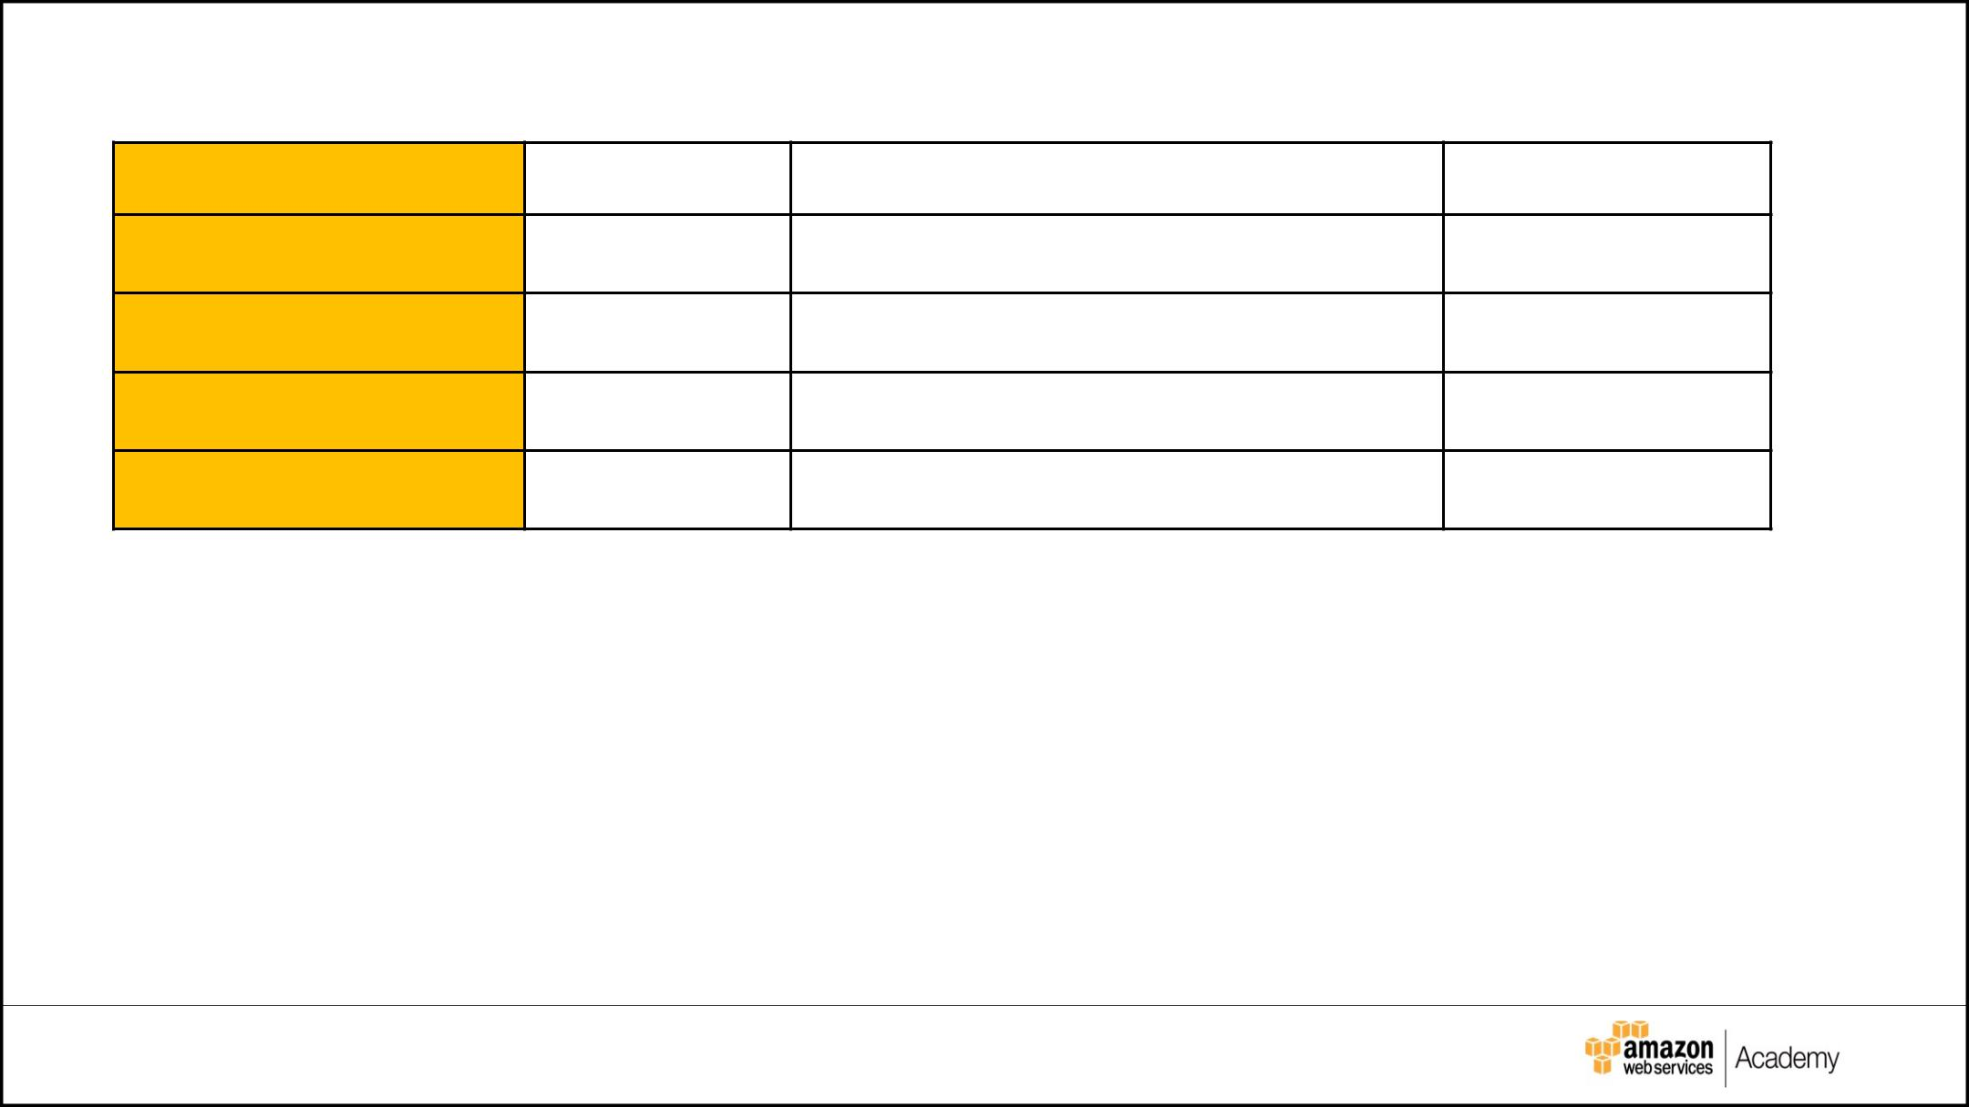

**Security Details**

|  |  |  |  |
| --- | --- | --- | --- |
| **Security Group** | **SG Name** | **Rule** | **Source** |
|  |  |  |  |

ELB load balancer

Web Tier

App Tier

Database Tier

|  |  |
| --- | --- |
| **Other Security Options** | **Justification** |
|  |  |
|  |  |
|  |  |
|  |  |
|  |  |

|  |  |  |  |
| --- | --- | --- | --- |
| © 2017 Amazon Web | Inc. and its affiliates. All rights reserved. | **14** |  |
| © 2016 Amazon Web ServicServices,Inc.and its affil ates. All rights reserved. | |  |

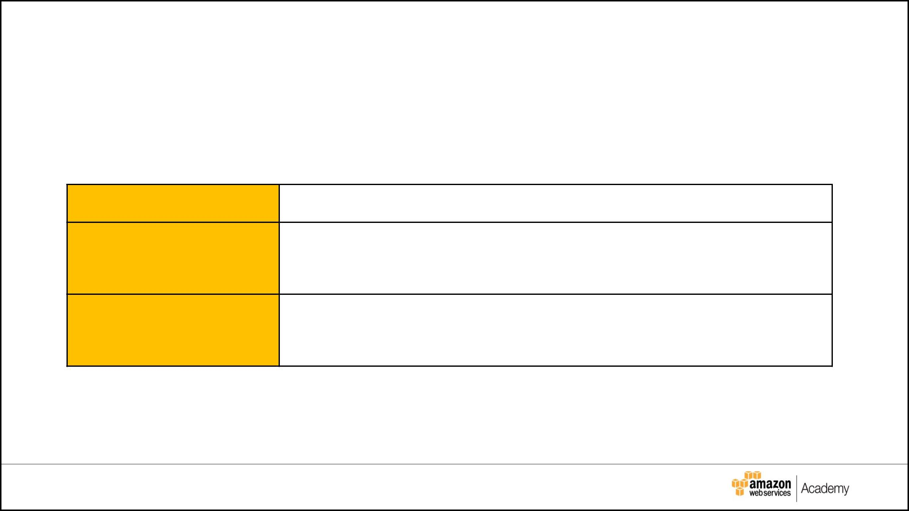

**Encryption Options**

Based on the requirements, list your encryption options:

|  |  |
| --- | --- |
| **Requirement** | **Solution** |
|  |  |

Encryption option for

**data at rest**

Encryption option for

**data in transit**

|  |  |  |  |
| --- | --- | --- | --- |
| © 2017 Amazon Web | Inc. and its affiliates. All rights reserved. | **15** |  |
| © 2016 Amazon Web ServicServices,Inc.and its affil ates. All rights reserved. | |  |



**Instance Details**

Describe the type, size, and justification for the instances you will use for each tier.

|  |  |  |  |  |  |  |
| --- | --- | --- | --- | --- | --- | --- |
| **Tier** | **AMI** | **Tag** | **Type** | **Size** | **Justification** | **# of instances** |
|  |  |  |  |  |  |  |
| Web |  | **Key: Name** |  |  |  |  |
|  |  | **Value: app-tier** |  |  |  |  |
|  |  |  |  |  |  |  |
| App |  | **Key: Name** |  |  |  |  |
|  |  | **Value: web-tier** |  |  |  |  |
|  |  |  |  |  |  |  |
| DB |  | **N/A** |  |  |  |  |
|  |  |  |  |  |  |  |

|  |  |  |  |
| --- | --- | --- | --- |
| © 2017 Amazon Web | Inc. and its affiliates. All rights reserved. | **16** |  |
| © 2016 Amazon Web ServicServices,Inc.and its affil ates. All rights reserved. | |  |

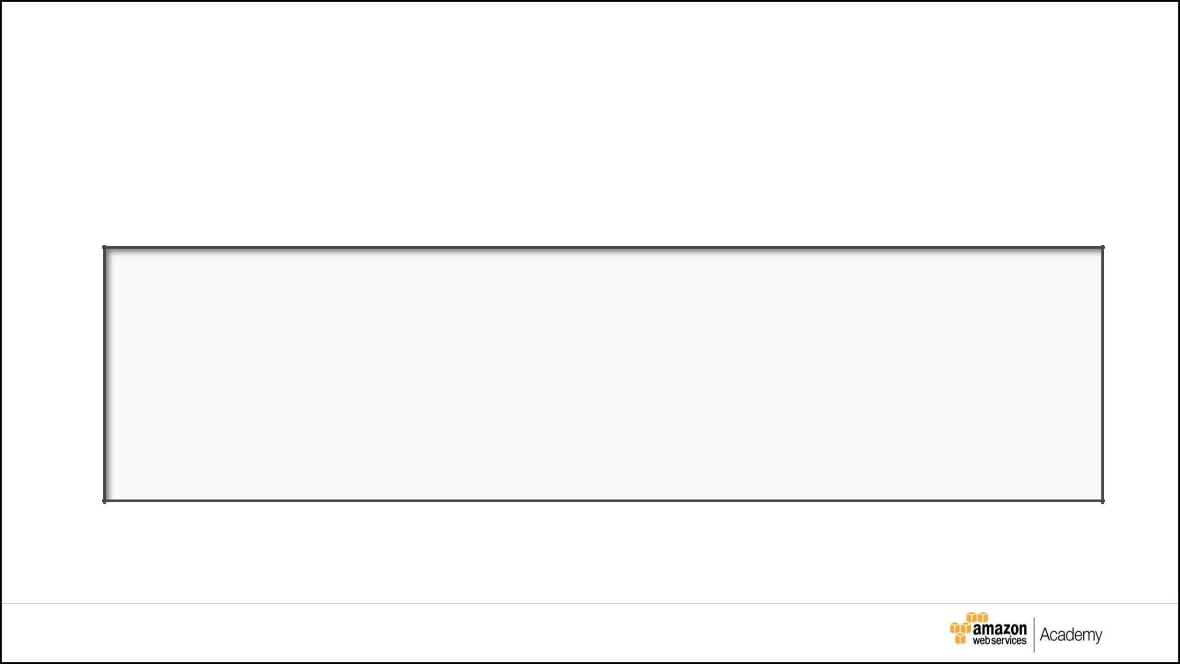

**RPO Options**

**Q.** How would you achieve a Recovery Point Objective (RPO) offour hours?

**A.**

|  |  |  |  |
| --- | --- | --- | --- |
| © 2017 Amazon Web | Inc. and its affiliates. All rights reserved. | **17** |  |
| © 2016 Amazon Web ServicServices,Inc.and its affil ates. All rights reserved. | |  |



**Document Storage**

How would you design document storage based on the requirements?

|  |  |
| --- | --- |
| **Storage/Archive** | **Detail** |
| **Option** |  |
|  |  |
|  |  |
|  |  |

|  |  |  |  |
| --- | --- | --- | --- |
| © 2017 Amazon Web | Inc. and its affiliates. All rights reserved. | **18** |  |
| © 2016 Amazon Web ServicServices,Inc.and its affil ates. All rights reserved. | |  |

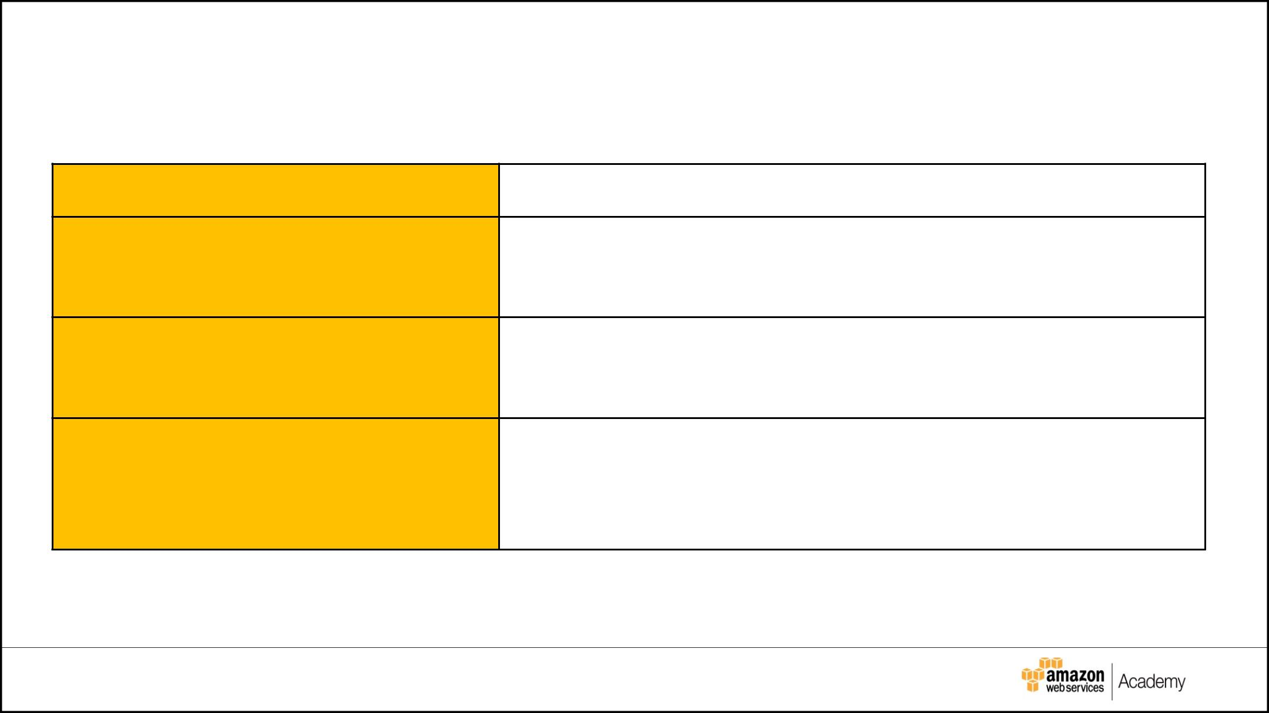

**Web Tier Requirements**

|  |  |
| --- | --- |
| **Requirement** | **Solution** |
|  |  |

Architecture must be flexible and handle

any peak in traffic or performance.

The overall acceptable incoming network

bandwidth is between 300 Mbps and 750

Mbps.

Application administrators want to be

notified by email if there are more than

100 “400 HTTP errors” per minute in the

application.

|  |  |  |  |
| --- | --- | --- | --- |
| © 2017 Amazon Web | Inc. and its affiliates. All rights reserved. | **19** |  |
| © 2016 Amazon Web ServicServices,Inc.and its affil ates. All rights reserved. | |  |



**App Tier Requirements**

|  |  |
| --- | --- |
| **Requirement** | **Solution** |
|  |  |
| Architecture must be flexible and |  |
| handle any peak in traffic or |  |
| performance. |  |
|  |  |
| Overall memory and CPU |  |
| utilization should not go above |  |
| 80% and 75% respectively or |  |
| below 30% for either. |  |
|  |  |
| Internet access is required for |  |
| patching and updates without |  |
| exposing the servers. |  |
|  |  |

|  |  |  |  |
| --- | --- | --- | --- |
| © 2017 Amazon Web | Inc. and its affiliates. All rights reserved. | **20** |  |
| © 2016 Amazon Web ServicServices,Inc.and its affil ates. All rights reserved. | |  |

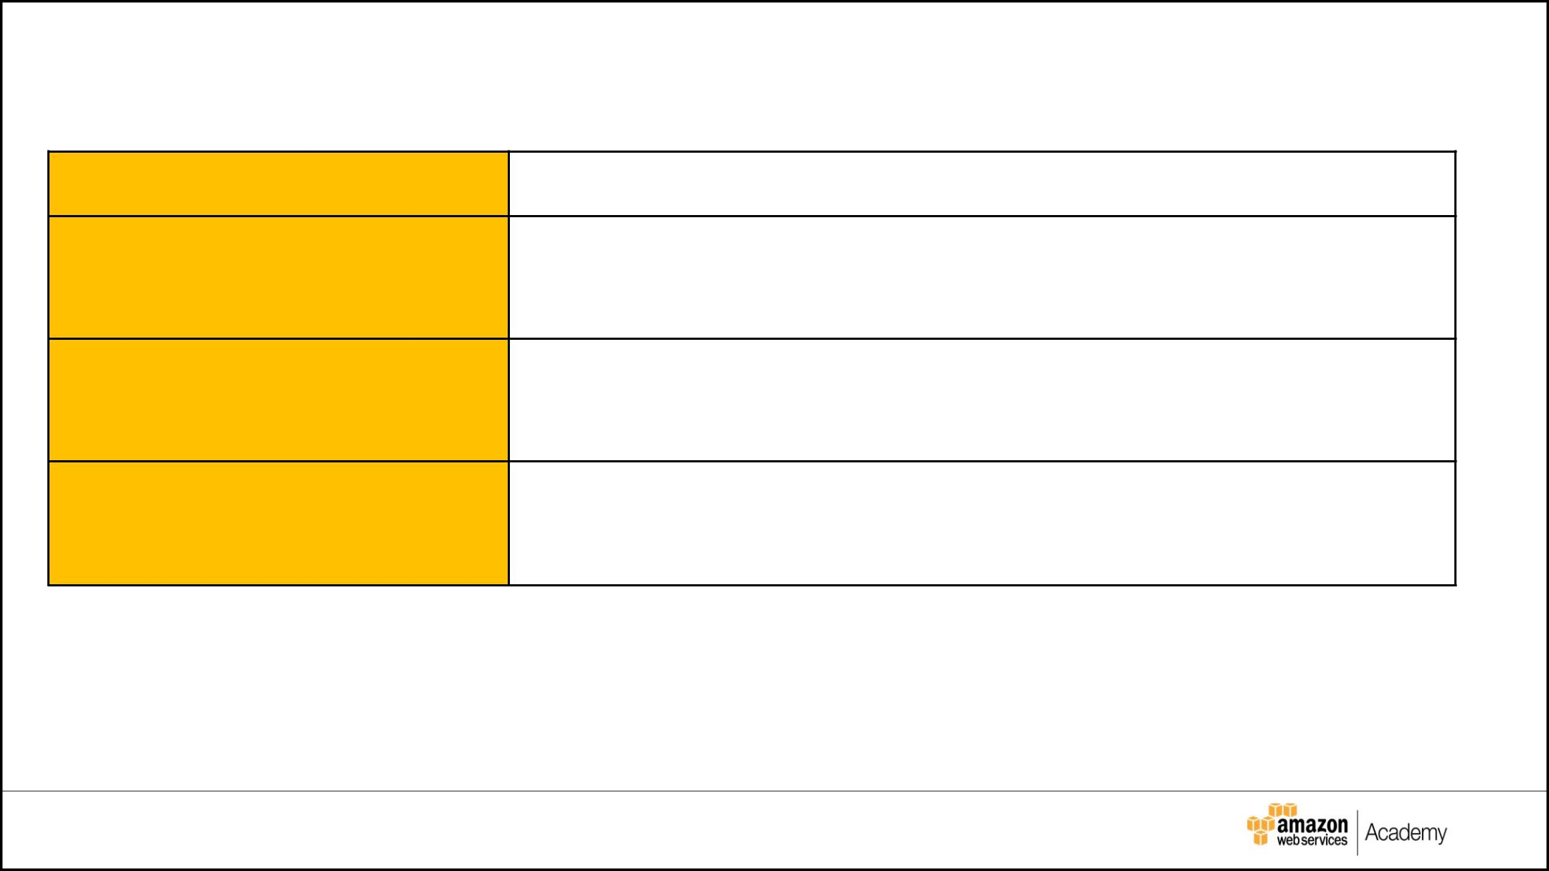

**Database Tier Requirements**

|  |  |
| --- | --- |
| **Requirement** | **Solution** |
|  |  |

Database needs consistent storage

performance at 21,000 IOPS.

High availability is a requirement.

No change to the database

schema can be made at this time.

|  |  |  |  |
| --- | --- | --- | --- |
| © 2017 Amazon Web | Inc. and its affiliates. All rights reserved. | **21** |  |
| © 2016 Amazon Web ServicServices,Inc.and its affil ates. All rights reserved. | |  |



**Additional Services**

List any additional AWS services that you would use for your solution and why?

|  |  |  |  |
| --- | --- | --- | --- |
| © 2017 Amazon Web | Inc. and its affiliates. All rights reserved. | **22** |  |
| © 2016 Amazon Web ServicServices,Inc.and its affil ates. All rights reserved. | |  |



**Cost Considerations**

Determine the following:

* Type of instances and payment models
* Number of instances
* Estimated monthly cost for the solution (Optional)

|  |  |  |  |
| --- | --- | --- | --- |
| © 2017 Amazon Web | Inc. and its affiliates. All rights reserved. | **23** |  |
| © 2016 Amazon Web ServicServices,Inc.and its affil ates. All rights reserved. | |  |



**Architecture Diagram**

AWS Simple Icons for Architecture Diagrams can be downloaded from:

<http://aws.amazon.com/architecture/icons/>

|  |  |  |  |
| --- | --- | --- | --- |
| © 2017 Amazon Web | Inc. and its affiliates. All rights reserved. | **24** |  |
| © 2016 Amazon Web ServicServices,Inc.and its affil ates. All rights reserved. | |  |



**Proposed Architecture Diagram**

|  |  |  |  |
| --- | --- | --- | --- |
| © 2017 Amazon Web | Inc. and its affiliates. All rights reserved. | **25** |  |
| © 2016 Amazon Web ServicServices,Inc.and its affil ates. All rights reserved. | |  |

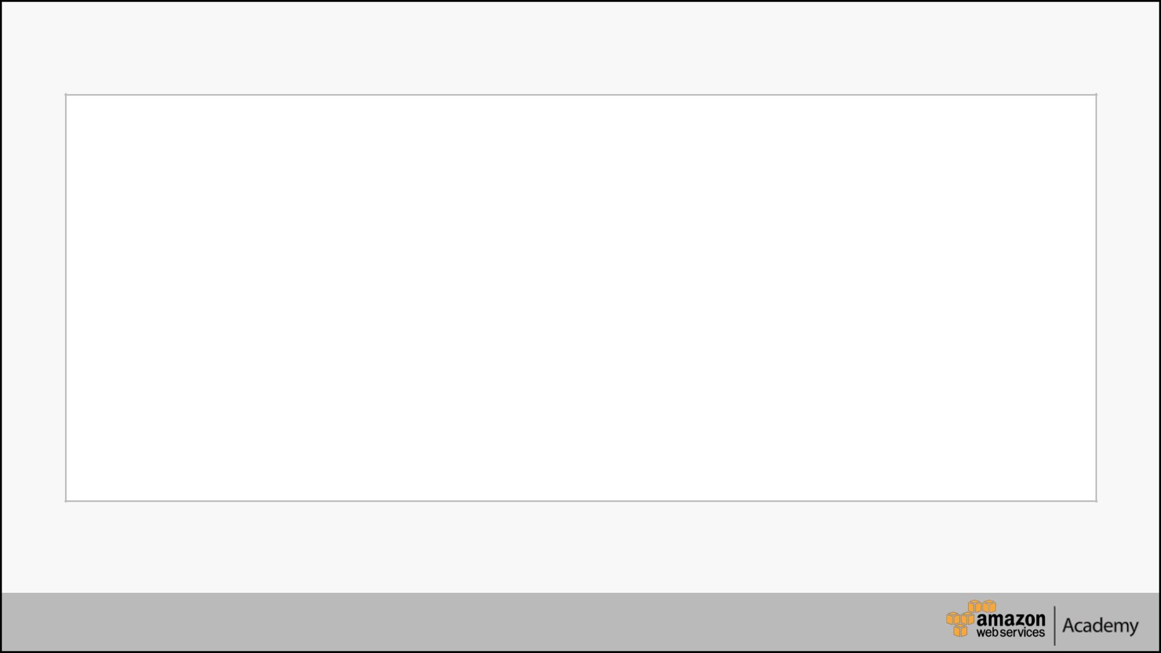

© 2017 Amazon Web Services, Inc. or its affiliates. All rights reserved.

This work may not be reproduced or redistributed, in whole or in part, without prior written permission from Amazon Web Services, Inc. Commercial copying, lending, or selling is prohibited.

Errors or corrections? Email us at [aws-course-feedback@amazon.com](mailto:aws-course-feedback@amazon.com).

For all other questions, contact us at

<https://aws.amazon.com/contact-us/aws-training/>.

All trademarks are the property of their owners.

© 2017 Amazon Web Services, Inc. or its affiliates. All rights reserved.